Exploring Text Data

Shonda Kuiper

May 21, 2017

Packages Installed: stringi,tm, RWeka, wordcloud

Useful packages not required for this RMD: readtext, and [quanteda](https://cran.r-project.org/web/packages/quanteda/vignettes/quickstart.html).

Introduction: In this lab, we will explore some common ways in text mining by creating corpus, transforming corpus, and creating document term matrices. We will also learn how to create n-grams, which is useful in text analysis. Lastly, we will use wordcloud package to generate a text visualization.

#### Reading Text Data

The readLines() function from base R can be used to read in the data.

#read in blogs, twitter and news  
Blogs1 <- readLines("C:/Users/KUIPERS/Desktop/RStudio/datasciencecoursera/NLP/final/en_US/en_US.blogs.txt", encoding = "UTF-8", skipNul = TRUE, warn = FALSE)  
Twitter1 <- readLines("C:/Users/KUIPERS/Desktop/RStudio/datasciencecoursera/NLP/final/en_US/en_US.twitter.txt",encoding = "UTF-8", skipNul = TRUE, warn = FALSE)  
News1 <- readLines("C:/Users/KUIPERS/Desktop/RStudio/datasciencecoursera/NLP/final/en_US/en_US.news.txt", encoding = "UTF-8", skipNul = TRUE, warn = FALSE)

#### Creating and Cleaning a Corpus

As described in the [tm package vignette](https://cran.r-project.org/web/packages/tm/vignettes/tm.pdf) A **Corpus** is a collection of text documents (all the writings or works of a particular kind or on a particular subject).

* VCorpus(x, readerControl): The default implementation is the so-called VCorpus (short for Volatile Corpus). These are R objects held fully in memory. We denote this as volatile since once the R object is destroyed, the whole corpus is gone.
* PCorpus implements a Permanent Corpus semantics, i.e., the documents are physically stored outside of R (e.g., in a database), corresponding R objects are basically only pointers to external structures, and changes to the underlying corpus are reflected to all R objects associated with it. Compared to the volatile corpus the corpus encapsulated by a permanent corpus object is not destroyed if the corresponding R object is released.

Since this is a computationally intensive process, we will use only a random sample of .2 percent of the data. We set a seed to ensure the random sample of the data provides exactly the same data each time the code is run.

set.seed(123)  
# Randomly Sample 1% of the lines without replacement  
Blogs2 <- sample(Blogs1, size=length(Blogs1)*.002, replace=FALSE)   
Twitter2 <- sample(Twitter1, size=length(Twitter1)*.002, replace=FALSE)   
News2 <- sample(News1, size=length(News1)*.002, replace=FALSE)   
  
data1 = c(Blogs2, Twitter2, News2)  
length1 = c(length(Blogs2),length(Twitter2), length(News2), length(data1))  
length1

## [1] 1798 4720 154 6672

The tm_map() function applies each transformation (tolower, stripWhitespace, ect..) to all elements of the corpus.

#???I think this gets rid of unneeded spaces. Only corpus,token and other dfm objects are accepted. If the class of data1 is a character we cannot immediately use the dfm function???  
data2 <- sapply(data1, function(x) iconv(enc2utf8(x), sub = "byte"))  
data2 <- (data2[!is.na(data2)])  
  
# Use the tm package to convert to a Volatile Corpus which realizes semantics known from most R objects and then conduct some basic data cleaning  
Corpus1 <- VCorpus(VectorSource(data2))  
Corpus1 <- tm_map(Corpus1, tolower) # Make all words lower case  
Corpus1 <- tm_map(Corpus1, removePunctuation) # Remove all punctuation  
Corpus1 <- tm_map(Corpus1, removeNumbers) # Remove all numbers  
Corpus1 <- tm_map(Corpus1, stripWhitespace) # Remove all whitespace  
Corpus1 <- tm_map(Corpus1, PlainTextDocument) # ???Remove all make plain text???  
profanity <- c("([Ff][Uu][Cc][Kk]",  
 "[Ss$][Hh][Ii][Tt]",  
 "[Aa@][Ss$][Ss$]",  
 "[Aa@][Ss$][Ss$][Hh][Oo][Ll][Ee]",  
 "[Cc][Uu][Nn][Tt]",  
 "[Dd][Aa][Mm][Nn]",  
 "[Nn][Ii][Gg][Gg][Ee][Rr])", sep="|")  
Corpus1 <- tm_map(Corpus1, removeWords, profanity)  
  
#Other common transformations include removing common words (a, the, or):  
#tm_map(abs, removeWords, stopwords("english")) # or  
#tm_map(Corpus1, removeWords, c(stopwords("english"),"my","custom","words"))   
#stem words (using only the root words?) #tm_map(Corpus1, stemDocument)  
#Corpus1 <- tm_map(Corpus1, toSpace, "/|@|\\|") #????

??? Can we make a list of common commands? What are other ways to remove profanity?

tm_map(Corpus1, tolower) # Make all words to lowercases

tm_map(Corpus1, removePunctuation) # Remove all punctuations

tm_map(Corpus1, removeNumbers) # Remove all numbers

tm_map(Corpus1, stripWhitespace) # Remove all whitespace

tm_map(Corpus1, removeWords, stopwords(“English”)) # Remove of stopwords

tm_map(Corpus1, stemDocument) # Stemming

??? other way to explain tdm and sparse terms???

A common approach is to create a term-document matrix from a corpus. In a term-document matrix, rows represent terms, columns are documents, and cell values are term frequency counts.

Since tdm(term-document matrices) tend to get very big for normal sized data sets, we use functions from tm package to remove sparse terms. Sparse terms are terms that occur only in very few documents. Normally, this reduces the matrix dramatically without losing significant relations inherent to the matrix.

inspect(removeSparseTerms(tdm, sparse = 0.4))

This function call removes those terms which have at least a 40 percentage of sparse. Sparse argument in removeSparseTerms()refers to the threshold of *relative document frequency* for a term, **above which** the term will be removed. Relative document frequency here means a proportion. For instance, 0.2 would remove most words and 0.99 will essentially keep all words.

#### Exploratory ngram Analysis

We are often interested in looking at common words or phrases withing the corpus.

We will use the RWeka package create 3 term-document matrices for unigrams, bigrams and rigrams. These are commonly referred to as **n-grams**, a contiguous sequence of n items from a given sequence of text or speech.

#UniTokens, BiTokens and TriTokens  
uniToken <- function(x) NGramTokenizer(x, Weka_control(min = 1, max = 1))  
biToken <- function(x) NGramTokenizer(x, Weka_control(min = 2, max = 2))  
triToken <- function(x) NGramTokenizer(x, Weka_control(min = 3, max = 3))  
  
uniTm <- TermDocumentMatrix(Corpus1, control = list(tokenize = uniToken))  
UniTm <- removeSparseTerms(uniTm, 0.8)  
  
biTm <- TermDocumentMatrix(Corpus1, control = list(tokenize = biToken))  
biTm <- removeSparseTerms(biTm, 0.999) #???Is this needed???  
  
#triTm <- TermDocumentMatrix(Corpus1, control = list(tokenize = triToken))  
#triTm <- removeSparseTerms(triTm, 0.8)

??? We need to describe what tokenizing is and view the actual tables to better understand the data and files?

A: Given a character sequence and a defined document unit, tokenization is the task of chopping it up into pieces, called tokens, perhaps at the same time throwing away certain characters, such as punctuation. Here is an example of tokenization:

Input: friends, roman, lend me your ears

Output: “friends”, “roman”, “lend”, “me”, “your”, “ears”

???Should we add how to save as .Rdata? What are the benefits of Rdata?

A: <http://www.fromthebottomoftheheap.net/2012/04/01/saving-and-loading-r-objects/>

This article points out that saveRDS() seems to be a better way of saving and loading objects in R. saveRDS() serializes an R object into a object that can be saved. As a result, the saved object can be loaded into a named object within R that is different from the name it had when originally serialized.

Creating a word cloud of the unigram data

???Add code to create wordclouds with and without stopwords?

Without stopwords:

Corpus1 <- tm_map(Corpus1, removeWords, stopwords(“yourWords”))

UniTm <- TermDocumentMatrix(Corpus1, control = list(tokenize = uniToken))  
UniTm <- removeSparseTerms(uniTm, 0.8)

Freq1 <- sort(rowSums(as.matrix(uniTm)), decreasing = TRUE)  
uniDF <- data.frame(word = names(Freq1), freq = Freq1)  
  
wordcloud(words = uniDF$word, freq = uniDF$freq, max.words=200,   
 random.order=FALSE, rot.per=0.1, use.r.layout=FALSE, ordered.colors=FALSE, colors=brewer.pal(6, "Dark2"))

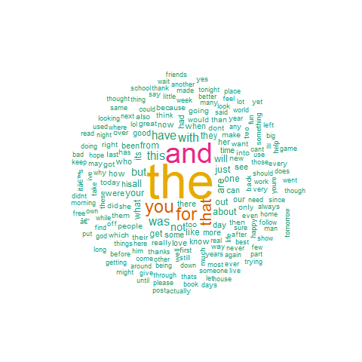

Creating a word cloud of the bigram data

Freq2 <- sort(rowSums(as.matrix(biTm)), decreasing = TRUE)  
biDF <- data.frame(word = names(Freq2), freq = Freq2)  
  
wordcloud(words = biDF$word, freq = biDF$freq, max.words=200,   
 random.order=FALSE, rot.per=0.1, use.r.layout=FALSE,  
 ordered.colors=FALSE, colors=brewer.pal(6, "Dark2"))

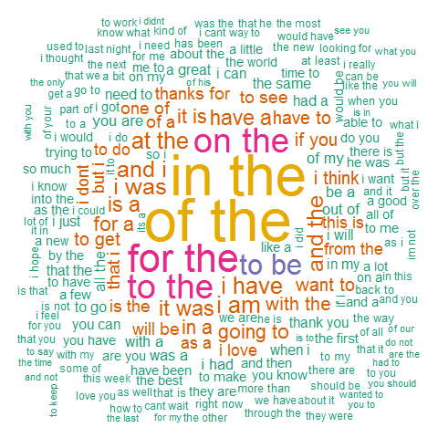

The most frequent ngrams

# The most common words(unigrams)  
head(uniDF,20)

## word freq  
## the the 5830  
## and and 3172  
## you you 1676  
## for for 1538  
## that that 1397  
## with with 907  
## this this 856  
## was was 854  
## have have 806  
## are are 713  
## but but 670  
## not not 611  
## all all 560  
## your your 534  
## just just 528  
## about about 476  
## will will 472  
## from from 464  
## out out 460  
## like like 438

# The most common word pairs (bigrams)  
#Freq2 <- sort(rowSums(as.matrix(biTm)), decreasing = TRUE)  
#biDF <- data.frame(word = names(Freq2), freq = Freq2)  
head(biDF, 20)

## word freq  
## of the of the 505  
## in the in the 484  
## for the for the 317  
## to the to the 274  
## on the on the 272  
## to be to be 214  
## i am i am 164  
## at the at the 159  
## i have i have 158  
## i was i was 157  
## and the and the 151  
## and i and i 150  
## it was it was 147  
## have a have a 137  
## is a is a 134  
## for a for a 130  
## in a in a 127  
## going to going to 124  
## it is it is 122  
## with the with the 116